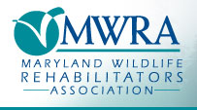
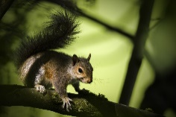
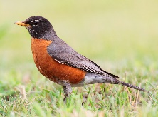
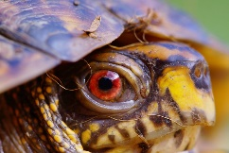
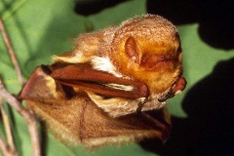
Annual Membership Application
This Photo by Unknown Author is licensed under CC BY-SA

2021-2022
I am a new member [ ] I wish to renew my annual membership [ ]

Enclosed is my check No.____________/money order in the amount of $30.00

First Name_________________________________ Last Name_________________________________

Street Address________________________________________________________________________

City_________________________ County________________ State ________ Zip Code______________

Cell Phone_____________________________ Other Phone____________________________________

Email address___________________________ Affiliation______________________________________

Please Provide your Wildlife Rehabilitator Status Master [ ] Apprentice [ ] Volunteer (No permit) [ ]
Please initial here [ ] if you wish to be included in the MWRA website (mwrawildlife.org) Referral Directory. A full copy of your permit(s) must be included with this application showing the Permit number, Expiration, location you are authorized to rehab and the species you are permitted to rehabilitate as stated on your permit(s).
We cannot refer or list you in the directory as a rehabilitator of a given species without a full copy of your valid permit(s).
Please contact us at info@mwrawildlife.org with any questions.
Please mail application with payment and enclosures to:
MWRA c/o Kathy Woods
Phoenix Wildlife Center 14530 Manor Road Phoenix, MD 21131

